POWER BI DASHBOARD CHALLENGE
TASK 3 – DATA MODELING
● Identify Fact table(s) and Dimension table(s).
● Build relationships (one-to-many / many-to-one).
● Check cardinality and cross-filter direction.
● ✅ Task: Create a clear and correct data model.
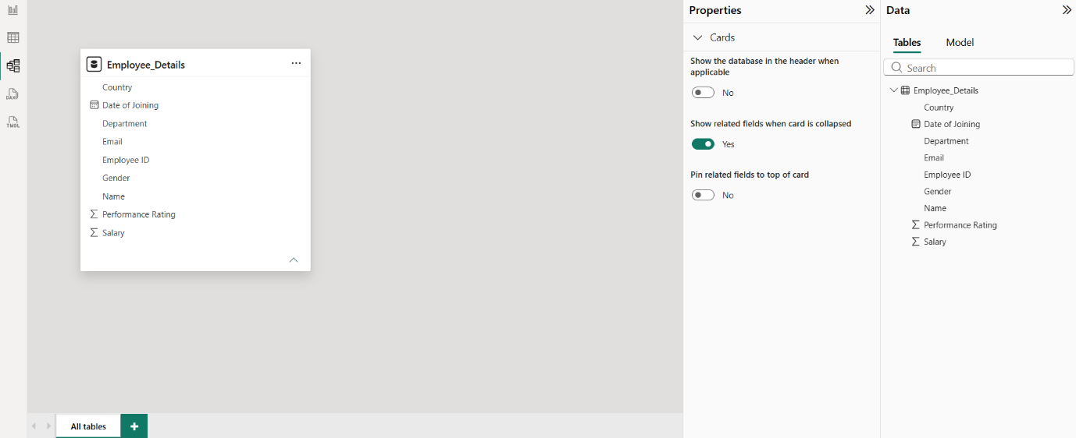
OBSERVATION:
1. The dataset contains a single table.
2. No fact and dimension tables were identified.
3. No relationships were required.
4. Cardinality is not applicable for a single-table model.
5. Cross-filter direction is not applicable.
6. The data model is simple and ready for visualization.

